Lab 3A

#include <stdio.h>
#define SIZE 5
int linq[SIZE], lfront=-1,lrear=-1;

void lin_insert(int x) ;
void lin_delete() ;
void lin_display() ;

int main(){
printf("Welcome to the linear queue \n");
int ch,x;
while(1){
printf("\n1.Insert Linear\n2.Delete Linear\n3.Display Linear\n4.Exit\nChoice: ");
scanf("%d",&ch);
switch(ch){
case 1: printf("Enter: ");
scanf("%d",&x);
lin_insert(x);
break;
case 2: lin_delete();
break;
case 3: lin_display();
break;
case 4: return 0;
default: printf("Invalid\n");
}
}
}

void lin_insert(int x){
if(lrear==SIZE-1) {
printf("Linear Queue Overflow\n");
}
else{
if(lfront==-1) lfront=0;
linq[++lrear]=x;
}
}

void lin_delete(){
if(lfront==-1) {
printf("Linear Queue Underflow\n");
}
else {
printf("Deleted from Linear Queue: %d\n",linq[lfront]);
lfront++ ;
}
}

void lin_display(){
if(lfront==-1||lfront>lrear) printf("Linear Queue Empty\n");
else{
printf("Linear Queue: ");
for(int i=lfront;i<=lrear;i++) printf("%d ",linq[i]);
printf("\n");
}
}

Output
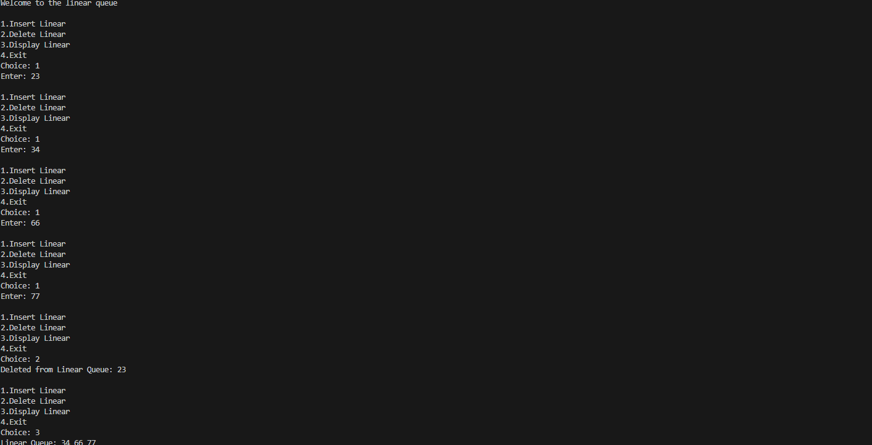

Lab 3 B

#include <stdio.h>
# define SIZE 5
int cirq[SIZE] , cfront = -1 , crear = -1 ;

void cir_insert(int x) ;
void cir_delete();
void cir_display();

int main() {
printf("Welcome to the circular queue \n");
int ch,x;
while(1){
printf("\n1.Insert circular\n2.Delete circular\n3.Display circular\n4.Exit\nChoice: ");
scanf("%d",&ch);
switch(ch){
case 1: printf("Enter: "); scanf("%d",&x); cir_insert(x); break;
case 2: cir_delete(); break;
case 3: cir_display(); break;
case 4: return 0;
default: printf("Invalid\n");
}
}

}

void cir_insert(int x){
if((crear+1)%SIZE==cfront) printf("Circular Queue Overflow\n");
else{
if(cfront==-1) cfront=0;
crear=(crear+1)%SIZE;
cirq[crear]=x;
}
}

void cir_delete(){
if(cfront==-1) printf("Circular Queue Underflow\n");
else{
printf("Deleted from Circular Queue: %d\n",cirq[cfront]);
if(cfront==crear) cfront=crear=-1;
else cfront=(cfront+1)%SIZE;
}
}

void cir_display(){
if(cfront==-1) printf("Circular Queue Empty\n");
else{
int i=cfront;
printf("Circular Queue: ");
while(1){
printf("%d ",cirq[i]);
if(i==crear) break;
i=(i+1)%SIZE;
}
printf("\n");
}
}

Output
